**EFP Analyzer: A fast, accurate, and easy-to-teach program for analyzing Extracellular Field Potentials from iPS-derived cardiomyocytes**

Original author list:

Andrew M. Glazer,1,2 Yuko Wada1,2, Shan Parikh,1,2 Laura Short,1,2, Marcia Blair,1,2 Lynn Hall,1,2 Björn C. Knollmann,1,2 Dan M. Roden1,2,3,4, Joe-Elie Salem, 1,2,5

Vanderbilt Center for Arrhythmia Research and Therapeutics1 and Departments of Medicine,2 Pharmacology,3 and Bioinformatics,4 Vanderbilt University Medical Center

5 INSERM, CIC-1421, Sorbonne Université, AP-HP, Pitié-Salpêtrière Hospital, Department of Pharmacology, UNICO-GRECO Cardio-oncology program, F-75013, Paris, France

*Corresponding author:* Andrew Glazer, andrew.m.glazer@vumc.org

**TO DO LIST**

**Get server access again**

**Fix bug in Christian’s program**

**Get EFPA working again**

**Make EFPA faster**

**Figure out permanent hosting solution—reach back out to Tech Transfer guy**

**Look through the dataset/figures we have—what more do we need**

**Write the paper**

**ABSTRACT**

**Rationale:** Induced pluripotent stem cell-derived cardiomyocytes (iPS-CMs) are an emerging model for determining drug effects and modeling disease. Automated devices can generate Extracellular Field Potential (EFP) measurements from these cells, analogous to the ventricular complex of the electrocardiogram.

**Objective:** The objective of this study was to develop an easy-to-use, easy-to-teach, reproducible software tool to measure EFPs.

**Methods-Results:** We present the EFP-Analyzer, a tool for analysis of EFP traces, which identifies and averages beats, identifies landmarks, and calculates intervals in a semi-automated manner. We evaluated the tool in an analysis of over 1000 EFP traces from 15 patient-derived lines. We analyzed spontaneously beating iPS-CMs, as well as cells expressing channelrhodopsin, which enabled optical pacing. We develop stringent quality criteria and accurately measured EFP intervals, including Field Potential Duration (named EFP-QT, by analogy to human electrocardiograms) corrected for heart rate by fridericia (EFP-QTc). FPD measurements were more accurate when using a tangent method. EFP-QTc from control paced IPS-CMs were shorter than those of spontaneously beating IPS-CMs (XX±XX vs. XX±XX, p:XX). Intraclass correlation coefficient for intra- and inter-observer measurements for these EFP-QTc ranged between r:XX-XX. Bland-Altman plots comparing two observers’ results showed 95% limits of agreement ranging from −XX to XXms and from −XX to XXms for spontaneously beating and paced iPS-CMs, respectively. The EFP-analyzer could accurately detect prolongation in EFP-QTc due to drug (moxifloxacin) or pathogenic mutations (*CACNA1C xxx*).

**Conclusions:** The EFP-Analyzer tool is a useful tool that enables the efficient use of iPS-CMs as a model to study drug effects and disease.

**INTRODUCTION**

Since their discovery in 2006,1 induced pluripotent (iPS) cells have become a transformative tool for modeling cell behavior, drug response, and disease.2 A number of groups have developed methods for differentiating iPS cells into cardiomyocytes (iPS-CMs).3 These cardiomyocytes are an emerging model for the study of drug safety screening, in particular for detecting drugs that prolong the cardiac action potential.4 iPS-CMs have also been used to study individual variability in electrocardiographic properties and drug response.5 In addition, gene-editing methods such as CRISPR allow further studies of mutation effects on IPS-CMs (refs). Recent advances in optogenetic methods have allowed for the expression of channelrhodopsin, a light activated ion channel, in iPS-CMs to enable optical pacing (ref?). Although iPS-CMs are thought to represent a relatively immature state of cardiac differentiation, recent methods have resulted in improved differentiation. 6 XX The Extracellular Field Potential is a measurement of a cardiomyocyte’s beating pattern, generated from electrodes adjacent to the cells of interest. EFPs can be considered analogous—but not identical—to the electrocardiogram (ECG).

Automated ECG analysis software is in widespread use, and extensive analyses have validated the consistency of these measurements.7 The heart has large conduction distances and regions with distinct beating patterns, such as the atria and ventricles. In contrast, iPS-CM monolayers are a relatively uniform substrate with small conduction distances. Although the EFP representation appears analogous to the ventricular complex (QRS and T wave) of the ECG (Figure XX), relatively little work has demonstrated the consistency or reliability of EFP measurements, including intra- and inter-observer reliability. In addition, no standardized analysis tools have been made to analyze EFP morphology and parameters. Previous studies have adapted ECG analyzers such as LabChart designed for *in vivo* animal analysis, used software built-in to the devices, or used custom analysis methods without assessing reliability of these strategies (refs).

In this study, we present the EFP-Analyzer, a semi-automated software tool for analysis of EFP traces. We use the EFP-Analyzer to analyze a large dataset of over 1000 control EFPs from XX control patients and provide guidelines for stringent quality criteria. We show that this tool is fast to use, and generates consistent, reliable measurements. The EFP Analyzer can accurately detect changes in FPD due to drugs or mutations. This tool will help enable the use of EFPs in iPS-CMs for drug screening and disease modeling.

**METHODS**

Generation of iPS lines: Patients were chosen who had no known congenital arrhythmia syndromes. All patient-derived lines were generated with patient consent under Vanderbilt IRB #040551. Peripheral blood mononuclear cells were isolated from blood and reprogrammed into iPSCs using electroporation delivery (Neon system, ThermoFisher) of non-integrating episomal vectors (Epi5 Episomal iPSC Reprogramming Kit, ThermoFisher). iPSC-like colonies were manually moved to hES-grade matrigel (Corning) coated 24-well plates between day 14-30 post-electroporation. Individual colonies were expanded for validation and line maintenance. Selected iPS cells were validated by staining with OCT4 (Cell Signaling, #2750), SSEA4 (DSHB, MC-813-70), SSEA3 (Millipore, MAB4303), and Tra1-60 (Millipore, MAB4360). All iPS lines used in this study were karyotype normal (Genetics Associates, Nashville, TN).

Cardiomyocyte differentiation

iPSC’s were cultured in mTeSR media for 4-5 days to achieve ~80% confluency. Media was changed to cardiac differentiation medium: RPMI 1640 (11875, Life Technologies), 2% B-27 minus insulin supplement (A1895601, Life Technologies), and 1% Penicillin-Streptomycin (Life Technologies). From days 0-2 the media was supplemented with 6 μM CHIR99021 (LC Laboratories), and from days 3-5 with 5 μM IWR-1 (Sigma). From days 13-19 metabolic selection medium was used: RPMI1640 without glucose (11879, Life Technologies), 2% B-27 minus insulin supplement (A1895601, Life Technologies), and 1% Penicillin-Streptomycin (Life Technologies). For days 19+ cardiomyocyte media was used. Media was exchanged every other day. Selected iPS-cardiomyocytes were validated by staining with alpha-actinin (Sigma). Optically paced cells were treated from days 28-30 with 6500 genome copies/cell of AAV1.CAG.hChR2(H134R)-mCherry.WPRE.SV40 (Addgene20938M) purchased from the University of Pennsylvania Vector Core. At day 30 cells were replated into CardioExcyte96 sensor plates (Nanion) coated with 50 µl of 1:100 Matrigel, and cells were studied at day 38-42 post-differentiation.

EFP measurement: EFP and impedance signals were measured on the CardioExcyte96 (Nanion) 8-12 days after replating (day 38-42 post-differentiation). Cells were kept at 37oC, 80% humidity, and 5% CO2. For optical pacing, a stimulating optical lid (Nanion) was used, which exposed all wells to 470nm wavelength light. Cells were exposed at 1 Hz to 5 msec-long pulses of light at 30 mA power. 20-30 second sweeps were recorded at an acquisition rate of 0.1 ms. Raw EFP and impedance measurements were converted into tab-delimited files and processed in the EFP-Analyzer tool.

EFP-Analyzer analysis: A flowchart of the analysis logic is presented in Figure Sx. After login, the user is first presented with a data input screen (Figure Sx) which allows the import of a tab delimited file containing Time in seconds in column 1 and EFP measurements from multiple samples (wells) in columns 2+. Alternatively, the user can also load a previously analyzed project. Upon loading the input files and selecting initial settings, screen 2 is presented, which contains the main analysis. The top plot displays the entire sweep, from which beats can be selected automatically or manually for analysis. Beats are averaged and displayed in plot 2. Beats deviating from the mean beat by more than the noise cutoff are eliminated. Landmarks for the Q point, the S point, the T peak, the Tend tangent point, and the Tend threshold point are selected automatically or manually (Figure Xx). The user can navigate between samples and choose which samples to include or exclude. Measurements and plots can be downloaded to the user’s computer as a series of .csv and .pdf files. Additional EFP Analyzer features are described in the supplemental methods.

Analysis of control EFPs: xxx control wells were selected across 10 AAV-treated and 10 non-AAV treated lines. All EFPs were classified by morphology into one of 3 categories (standard, low amplitude, biphasic). Low amplitude traces were defined as traces with a repolarization wave maximal amplitude (T peak) less than 15 uV. Biphasic traces were defined as those having two distinct repolarization waves in opposite directions, each later than 50 ms after the beginning of depolarization. Each EFP was then measured with the EFP Analyzer tool as described above. XX

Analysis of EFPs after exposure to an IKr-Blocker or to pathogenic genetic variant in CACNA1C: Moxifloxacin (source) was applied to selected cells in increasing doses (10 uM, 30 uM, 100 uM, 300 uM) at 1 hour intervals. **CACNA1C cells.** Statistical analyses were performed in R.

**RESULTS.**

Description of EFPA-Analyzer software tool

We developed the EFPA-Analyzer software tool, a Shiny-based interactive tool, available at [website]. The tool consists of a login screen, a data load screen, and a data analysis screen (Figure 1, Sx). In the data load screen, users upload a dataset of EFP signal versus time, formatted in a comma separated values (.csv) file, and select analysis parameters. In the data analysis screen, beats are selected and averaged, landmarks are placed and intervals are calculated. The philosophy of the program is that it is “semi-automated” and landmarks resemble to the one used to evaluate ventricular depolarization (QRS) and repolarization processes (QT, QTc when corrected for heart rate) in human ECG. Thereof, these parameters are named EFP-QRS, EFP-QT and EFP-QTc (Figure XX). The program makes an attempt to perform these tasks automatically once a new well is loaded. Users can modify the beat location and landmark placement. A full tutorial and example dataset is available in Supplemental File X.

Analysis of 15 iPS-CM lines

We applied the EFPA-Analyzer to EFPs generated from the CardioExcyte96, a 96-well plate format EFP generator from Nanion. We analyzed 15 iPS-CM lines derived from individuals without apparent genetic arrhythmia disorders. We analyzed a total of 10xx traces (8-150 per line). Some traces were analyzed with spontaneous beating, and some were treated with an AAV-ChR and optically paced. From an initial dataset of 708 spontaneous and 572 optically paced traces, wells that were not beating or irregularly beating were excluded leaving 430 spontaneous and 260 AAV traces (Figure 2). We determined the consistency of the EFPA-Analyzer to measure QT on EFP traces as a function of EFP morphology classified into 3 categories (standard, low amplitude, biphasic) (Figure XX). A random selection of XXX paced and XXX unpaced traces (stratified by EFP repolarization morphology) were repeated in measurement by an expert (AG), and by a novice (YW) who had a training session of XX hours in how to analyze the data and use the tool (XX EFP test measurements). The consistency and bias, the mean difference between repeat measurements as a function of morphology traces are displayed in Supplementary Table XXX and supplementary Figure XX. The EFP with a standard morphology had the highest level of measurements reproducibility while EFP with low amplitude or biphasic morphology were poorly reproducible and highly scattered (Table XX).

Therefore, we focused for the subsequent analyses only on the EFPs with standard morphology, leaving in the end 303 (303/708, 43%) spontaneous and 181 (181/572, 32%) high-quality AAV-ChR traces that comprised the main dataset. All traces were measured by an expert analyzer (AG). Two methods were used, a simple threshold method and a tangent method, based on the different QTc measurement techniques used in human ECGs (ref, Fig 1). QT was corrected for rate by XXX method to achieve independence of QTc from heart rate (Figure or sup data). XXX. EFP-QT duration assessment by tangent method was shorter and carried a lowest dispersion than the EFP-QT duration assessed by threshold method (XX±XX vs. XX±XX, p:XX, respectively, table XX). Among the EFP-QTc (tangent method) measured by two observers, bland-Altman plots results showed a 95% limits of agreement ranging from −XX to XXms and from −XX to XXms for spontaneously beating and paced iPS-CMs, respectively (Figure and Table). Among the EFP-QTc (tangent method) measured by the same expert observers, bland-Altman plots results showed a 95% limits of agreement ranging from −XX to XXms and from −XX to XXms for spontaneously beating and paced iPS-CMs, respectively (Figure and Table). Intraclass correlation coefficient for intra- and inter-observer measurements for these EFP-QTc (tangent method) ranged between r:XX-XX (Supp Figure XX). EFP-QTc (tangent method) were shorter in the group of paced EFP vs. spontaneous EFP (XX±XX vs. XX±XX, respectively) partly due to shorter EFP-QRS in the group of paced EFP vs. spontaneous EFP (XX±XX vs. XX±XX, respectively). Data concerning bland-Altman plots and intraclass correlation coefficient for intra- and inter-observer for EFP-QTc measured by threshold method are provided in Table XX and Supp data XX. Data concerning differences between spontaneous and paced EFP for EFP-QTc measured by threshold method shared the same trend that with EFP-QTc measured by tangent method and are displayed in Table XX and Supp data XX.

XXX

Application to drug response and disease

We analyzed the EFP-Analyzer tool’s ability to identify changes to EFP pattern/landmarks in response to drugs and in the case of individuals with disease. We first analyzed the action potential-prolonging drug moxifloxacin, which is a blocker of the human a gogo (hERG) channel. We successfully detected an increase in EFP-QTc in response to increasing doses of moxifloxacin, with ~100 ms prolongation at 100 uM (Figure XX). Next, we analyzed a cell line with a congenital Long QT syndrome 8 mutation in *CACNA1C* called NxxxD. These cells were compared to isogenic controls that had not been CRISPR-edited. We also detected a difference between the wild-type and mutant iPS line (50 ms mean difference in EFP-QTc, p=xxx). We therefore have the ability to detect changes in FPD due to drugs or mutations.

**DISCUSSION.**

The EFP Analyzer is a fast, consistent tool for data analysis

The EFP Analyzer is a fast, consistent tool for data analysis. The data derived from FPD’s is robust and consistent between multiple observers expert/expert or expert/novice. For example, the mean difference between observers was 20-25 ms for unpaced and 8-12 ms for paced cells. This is approaching the robustness achievable in an ECG’s, typically considered to be around 5-10 ms (ref). We believe that the uniform simultaneous depolarization of an entire well with optical pacing led to a more reproducible (and 25 ms shorter) FPD than the spontaneous activation of cells in a well, which signal has to spread throughout the whole well.

Recommendations for improving EFP quality/robustness

We observed a range of EFP morphologies, which we termed standard, low amplitude, and biphasic. We found that according to a variety of metrics, low amplitude and biphasic EFPs generated non-robust data, leading to highly variable, inconsistently measured values. We therefore recommend that these classes be removed. Our tangent approach also improved the robustness of the EFPs according to these metrics. We note that these parameters were optimized on EFPs generated from one device, the Nanion CardioExcyte 96. Other instruments may differ in which traces are high-quality.

Recommendations for improving EFP quality/robustness

For ECG analysis, a return to baseline of the QT is commonly used. However, in some cases the T wave has a big extended unclear return to baseline particularly the lower the T peak is in term of amplitude, and a tangent method (drawn at the steepest point) yields more robust QT measurements (ref). We observed that some EFPs had long extended repolarization waves, analogous to T waves in the ECG. We hypothesized that a similar logic could be used, and that a tangent method could be better than a simple return to baseline approach. We compared the tangent and approach to baseline with the following metrics. We observed a decrease in the standard deviation of the measurement across many wells, which suggests that the result is getting more accurate/repeatable. We also observed that in repeated measurements across multiple observers the tangent method was more robust.

Comparison to other methods/tools

The CardioExcyte 96 has built in software to calculate intervals, however we found that the EFP Analyzer was a better fit for analyzing the data flexibly and storing and managing the data. The EFP Analyzer was faster than LabChart, and had increased capabilities, such as the tangent method, an option to manually adjust the beat locations, and persistent data storage. XX. Compare to that one TK told me about? One advantage of the EFP Analyzer is that it is semi-automated; for many traces it correctly identifies all the landmarks without any manual changes. Other EFPs with complicated/unclear patterns or with high background/artifact need manual intervention to optimize. Another advantage is that it acts as a data organizer that saves data. We frequently have one individual analyze the data, then another researcher review the data and edit it.

XX COMPARISON of EFP-QTc diff shown with EFP-QTc IPS-CM vs correspondence to that shown in human at circulatinng concentration of moxifloxacin (5-10 msec I guess). Same thing for the difference seen with QTc in patients with the proband carrier of the studied CACNA1C mutation vs. non-carrier in the same family.

Limitations

There are several limitations to this method. The cell lines we used were mainly based out of 2 labs at 1 site, and therefore might not be representative of other sites. We also have applied the EFP Analyzer tool to data generated from one type of device, the Nanion CardioExcyte 96. Other devices such as MEA’s may generate EFP’s with different characteristics. However, we believe that all datasets with shape fundamentally similar to the EFPs should be analyzable by the EFP Analyzer. XXXX

Funding

This research was funded by P50-GM115305 from the National Institute for General Medical Sciences. A.M.G. was supported by F32 HL137385 and T32 HG008341.

**Figure 1**

Please, put the 0 baseline voltage at the correct level…

i.e. lowest repol point

**EFP-QTc threshold**

**EFP-QTc Tangent**

**EFP-QRS**

Figure 2.

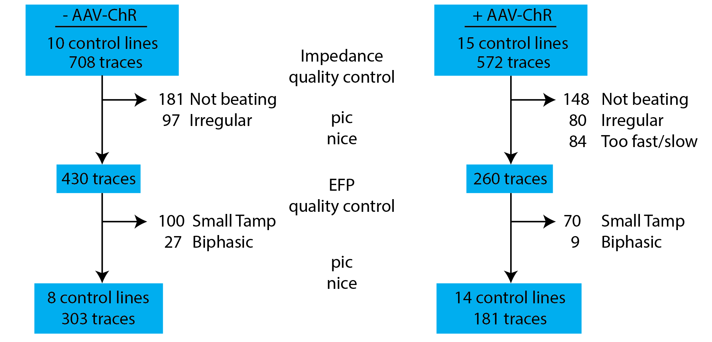

Figure 3

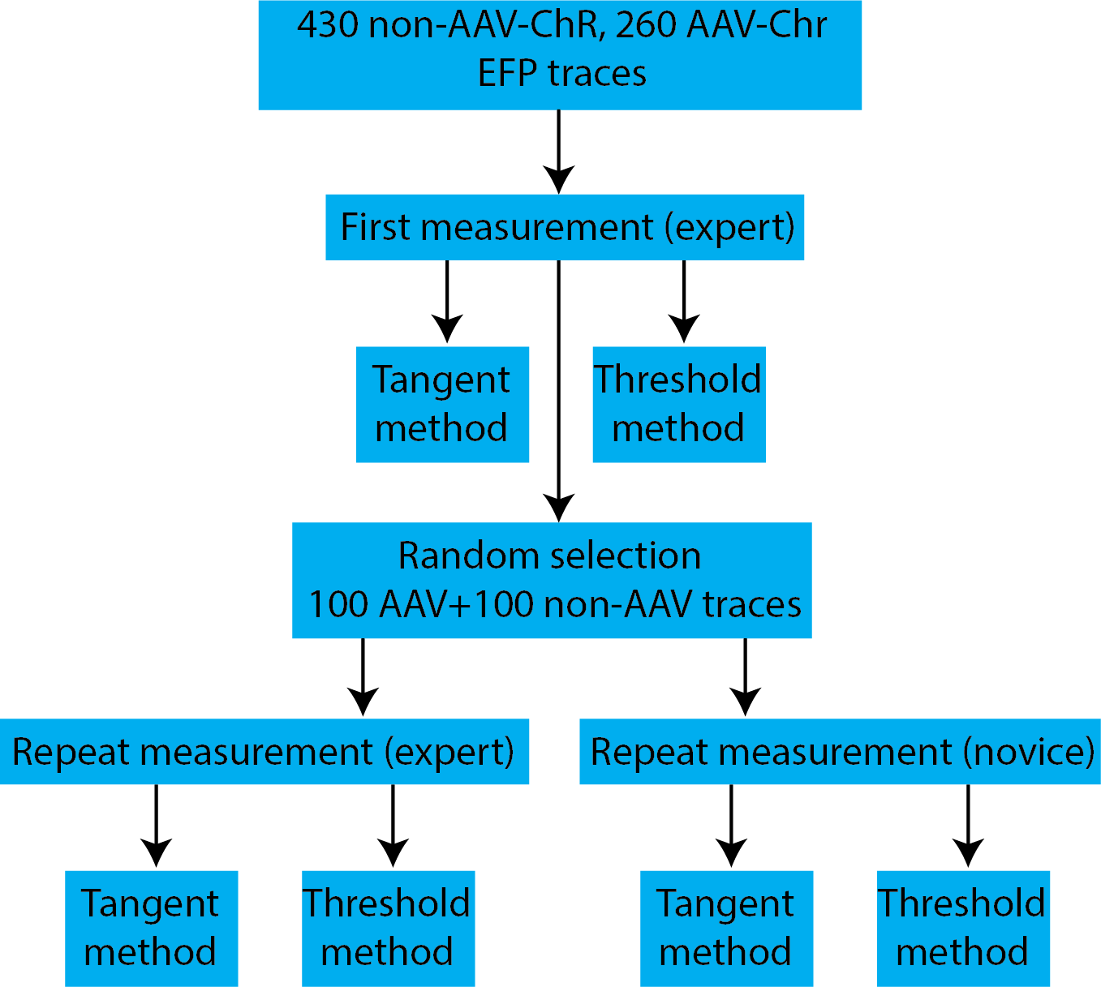

Figure 4



Figure 5.

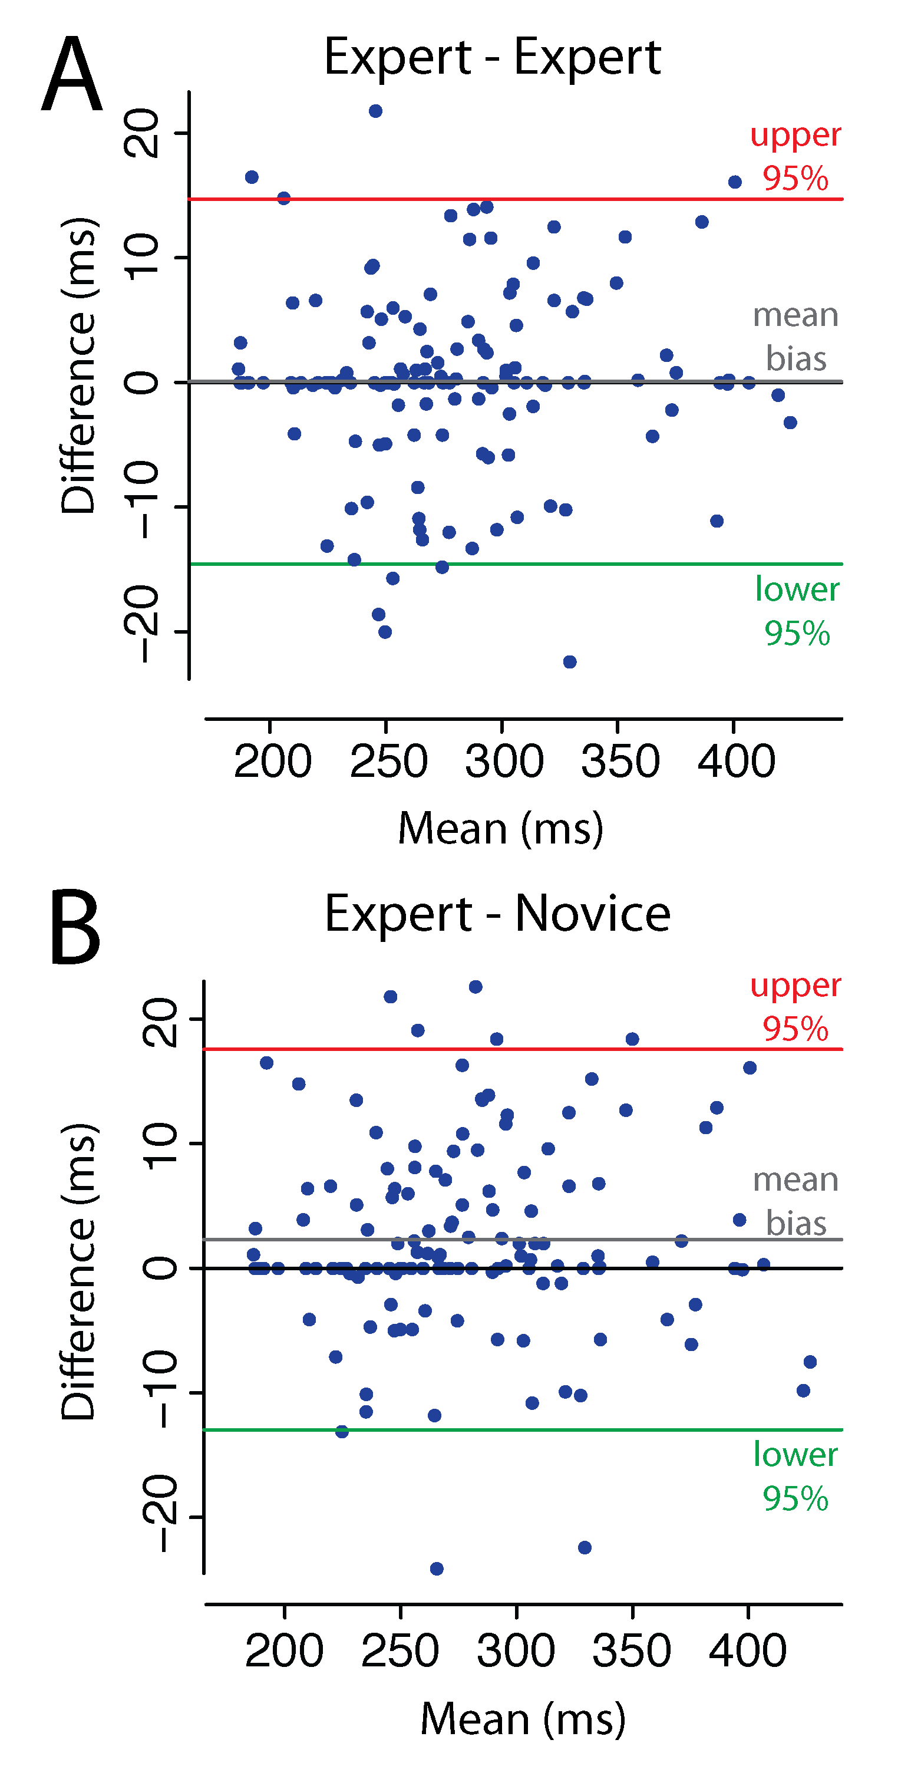

Break down by AAV+ vs AAV-?

Figure 6

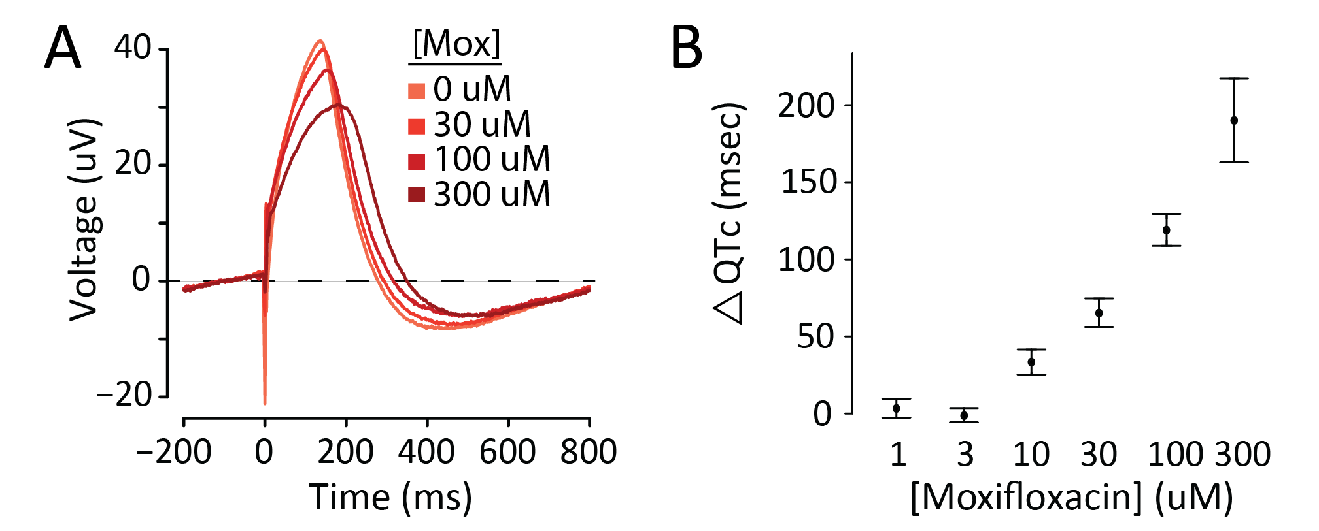

add in CACNA1C

**Table 1.**

|  |  |  |  |  |  |  |  |
| --- | --- | --- | --- | --- | --- | --- | --- |
| **AAV-ChR** | **Morphology** | **Number of wells** | **Heart rate**  **(Bpm)** | **EFP-QRS** | **EFP-QTc tangent** | **EFP-QTc threshold** | **EFP-QTc tangent**  **vs. threshold**  **p-values** |
| No | Standard | 303 |  | 58.7 (18.9) | 331.9 (85.0) | XX (XX) |  |
| Small Tamp | 100 |  | 60.2 (21.2) | 499.8 (83.5) | XX (XX) |  |
| Biphasic | 27 |  | 50.4 (20.8) | 553.7 (138.1) | XX (XX) |  |
| Yes | Standard | 181 |  | 23.9 (14.8) | 271.0 (53.9) | XX (XX) |  |
| Small Tamp | 70 |  | 27.1 (25.8) | 462.0 (211.1) | XX (XX) |  |
| Biphasic | 9 |  | 47.5 (28.9) | 389.9 (79.7) | XX (XX) |  |
| **AAV-ChR** (Yes vs. No) p-values | Standard | NA |  |  |  |  | NA |
| Small Tamp |  |  |  |  |
| Biphasic |  |  |  |  |

*Abbreviations*:

**Table 2.**

|  |  |  |  |  |  |  |  |  |
| --- | --- | --- | --- | --- | --- | --- | --- | --- |
| **AAV-ChR** | **Morphology** | **Number of wells analyzed** | **EFP-QTc tangent**  **consistency expert-expert** | **EFP-QTc tangent consistency expert-novice** | **EFP-QTc threshold**  **consistency expert-expert** | **EFP-QTc threshold consistency expert-novice** | **p-values**  **EFP-QTc tangent vs. threshold**  **consistency expert-expert** | **p-values**  **EFP-QTc tangent vs. threshold**  **consistency expert-novice** |
| No | Standard | XXX | -3.3 (21.8) | -1.0 (28.1) | XXX | XXX |  |  |
| Small Tamp | XXX | -2.4 (18.1) | -1.5 (51.1) | XXX | XXX |  |  |
| Biphasic | XXX | -19.7 (60.4) | -40.1 (102.2) | XXX | XXX |  |  |
| Yes | Standard | XXX | -0.2 (8.8) | 1.9 (7.5) | XXX | XXX |  |  |
| Small Tamp | XXX | -5.3 (36.3) | -6.5 (43.6) | XXX | XXX |  |  |
| Biphasic | XXX | -2.5 (27.5) | 8.5 (12.0) | XXX | XXX |  |  |

*Abbreviations*:

Literature Cited

1. Takahashi K, Yamanaka S. Induction of pluripotent stem cells from mouse embryonic and adult fibroblast cultures by defined factors. Cell. 2006;126(4):663-76. Epub 20060810. doi: 10.1016/j.cell.2006.07.024. PubMed PMID: 16904174.

2. Shi Y, Inoue H, Wu JC, Yamanaka S. Induced pluripotent stem cell technology: a decade of progress. Nat Rev Drug Discov. 2017;16(2):115-30. Epub 20161216. doi: 10.1038/nrd.2016.245. PubMed PMID: 27980341; PMCID: PMC6416143.

3. Denning C, Borgdorff V, Crutchley J, Firth KS, George V, Kalra S, Kondrashov A, Hoang MD, Mosqueira D, Patel A, Prodanov L, Rajamohan D, Skarnes WC, Smith JG, Young LE. Cardiomyocytes from human pluripotent stem cells: From laboratory curiosity to industrial biomedical platform. Biochim Biophys Acta. 2016;1863(7 Pt B):1728-48. Epub 20151031. doi: 10.1016/j.bbamcr.2015.10.014. PubMed PMID: 26524115; PMCID: PMC5221745.

4. Colatsky T, Fermini B, Gintant G, Pierson JB, Sager P, Sekino Y, Strauss DG, Stockbridge N. The Comprehensive in Vitro Proarrhythmia Assay (CiPA) initiative - Update on progress. J Pharmacol Toxicol Methods. 2016;81:15-20. Epub 20160607. doi: 10.1016/j.vascn.2016.06.002. PubMed PMID: 27282641.

5. Stillitano F, Hansen J, Kong CW, Karakikes I, Faunck-Brentano C, Geng L, Scott S, Reynier S, Wu M, Valogne Y, Desseaux C, Salem JE, Jeziorowska D, Zahr N, Li R, Iyengar R, Hajjar RJ, Hulot JS. Modeling susceptibility to drug-induced long QT with a panel of subject-specific induced pluripotent stem cells. Elife. 2017;6. doi: ARTN e19406

10.7554/eLife.19406. PubMed PMID: WOS:000393403900001.

6. Parikh SS, Blackwell DJ, Gomez-Hurtado N, Frisk M, Wang L, Kim K, Dahl CP, Fiane A, Tonnessen T, Kryshtal DO, Louch WE, Knollmann BC. Thyroid and Glucocorticoid Hormones Promote Functional T-Tubule Development in Human-Induced Pluripotent Stem Cell-Derived Cardiomyocytes. Circ Res. 2017;121(12):1323-30. Epub 20171002. doi: 10.1161/CIRCRESAHA.117.311920. PubMed PMID: 28974554; PMCID: PMC5722667.

7. Saque V, Vaglio M, Funck-Brentano C, Kilani M, Bourron O, Hartemann A, Badilini F, Salem JE. Fast, accurate and easy-to-teach QT interval assessment: The triplicate concatenation method. Arch Cardiovasc Dis. 2017;110(8-9):475-81. Epub 20170511. doi: 10.1016/j.acvd.2016.12.011. PubMed PMID: 28501559.